**Cotton Crop Disease Detection**

**With Deep Learning**



*By*

**Muhammad Shadab**

**(160397)**

***Supervised By***

**Dr. Atif Khan**

**2020**

**Department of Computer Science**

**Islamia College University Peshawar Session 2016-2020**

**Cotton Crop Disease Detection**

**With Deep Learning**



**Muhammad Shadab**

*Project Thesis Submitted to Department of Computer Science in Partial Fulfillment of the Requirement for the Degree of BS-Computer Science*

Approved by: **Dr. Atif Khan**

**Islamia College University Peshawar**

**Department of Computer Science Session 2016-2020**

**Approval Sheet**

We hereby recommend that the project entitled “**Cotton Crop Disease Detection With Deep Learning**” submitted by **Muhammad Shadab** is accepted as fulfilling the requirement for the degree of BS Computer Science.

**Supervisor: _____________________________** Dr. Atif Khan

Assistant Professor

Department of Computer Science

Islamia College, Peshawar

**External Examiner:** _____________________________

**Chairman: _____________________________** Dr. Zahoor Jan Associate Professor

Department of Computer Science

Islamia College, Peshawar

**Dated**: ____________________.

**ACKNOWLEDGEMENT**

First and foremost I would like to thank ALLAH, who gave me the courage and support to continue my graduate studies and project. The determination granted by ALLAH helped me to tolerate the hard times during my graduate studies and this project.

I offer my countless salutations upon the HOLY PROPHET MUHAMMAD (Peace Be upon Him) the entire source of guidance for the humanity as a whole forever.

I would like to express my most sincere gratitude to my supervisor Assistant Professor Dr. Atif Khan for his support, encouragement, and guidance through every step of this Project. Working with him has been a true privilege and a great experience for me. It has been a real honor for me to work under his supervision. I want to appreciate all the teachers of the Islamia College University Peshawar. They taught me during my course work, by delivering their precious and valuable thoughts, and built my concepts.

I would like to thank my parents and siblings whose efforts, financial support, love, guidance and prayers made it possible for me to complete graduate studies and this project.

Muhammad Shadab

Abstract

**World population is expected to be 10 billion in 2050. With more mouths to feed, agriculture needs to boost up to meet the food requirements. However, developing countries like Pakistan has seen a decline in their production of the crops. One of the main reasons behind declined in the production of the cotton crop is the damage caused by cotton diseases. Our model is giving farmers an easy and efficient method to diagnose cotton diseases and will recommend the usage of pesticides. It is based on machine learning, which learns with every use. Agriculture needs innovative ideas to increase its yield. Cotton Care (Cotton Crop Disease Detection using Deep Learning) is also one of the steps to integrate artificial intelligence into agriculture. The goal of this project is to help the farmers in decreasing the production cost and achieving the higher yield, which is also going to contribute to the country’s economy.**

Contents

CHAPTER 1 8

INTRODUCTION 8

1.1 Overview 8

1.2 Background 8

1.3 Problem Statement 9

1.4 Study Objectives 9

1.4.1 Deep learning 9

1.4.2 Web application 10

1.4.3 Programming Skills: 10

CHAPTER 2 11

LITERATURE REVIEW 11

2.1 Overview 11

2.2 Crop: Plant Disease Identification Using Mobile App. 11

2.2.1The Cause and Introduction. 11

CHAPTER 3 14

PROJECT TOOLS 14

3.1 Overview 14

3.2 Programming Language 14

3.2.1 Python 14

3.3 Software And Development Platform 15

3.3.1 Jupyter Notebook: 15

3.3.2 Datasets: 15

3.3.3 Keras 16

3.3.4 Matplotlib 17

3.3.5 Spyder IDE 18

3.3.6 Flask 19

3.3.7 HTML 20

3.3.8 CSS 21

CHAPTER 4 22

METHODOLOGY 22

4.1Overview: 22

4.2 Datasets: 22

4.3 Model building: 23

4.3.1 Image Augmentation : 23

4.3.2 Training: 24

4.3.2.1 Convolutional Neural Network: 24

4.3.2.2 Rectified Linear Units (ReLU): 25

4.3.3 Testing: 26

4.3.4 Model Accuracy: 26

4.2.5 Model Loss 27

4.3.1 Diseased Cotton plant: 29

4.3.2 Healthy Cotton Plant: 30

4.3.3 Healthy Cotton plant Leaf: 31

CHAPTER 5 32

ADVANTAGES & LIMITATIONS 32

5.1 Overview 32

5.2 Advantages: 32

5.3 Limitations 32

CHAPTER 6 33

CONCLUSION AND FUTURE WORK 33

6.1 Overview 33

6.2 Conclusion: 33

6.3 Future Work: 34

References 36

# CHAPTER 1

# INTRODUCTION

## Overview

In this chapter the details of the project are briefly described including the Background knowledge of the project, the Problem Statement of the project and the Study Objectives.

## Background

Agriculture majorly contributes Pakistan's economy as this sector contributes around 20% of GDP (Gross Domestic Products) and 65% of the country's exports in which cotton and cotton-based products have a significant share of 73%. But the cotton production has been declined in the past few years due to increasing production cost and damage done by the cotton diseases. The farmers face a major challenge is proper diagnoses to save the cotton crop. So, our project will present a technique to detect the insect-based diseases in the cotton crop by deep learning.

Cotton is a major crop of Pakistan after wheat and it occupies the largest area in Pakistan compared to other crops. Cotton crop earns the country's largest export revenues and in addition to the lint, In developing countries like Pakistan, the economy mainly depends on agriculture. Due to plant diseases, the quality and quantity of agricultural products are reduced. Diseases to the plants are caused mainly by fungi and bacteria and the lifecycle of micro-organism is unable to predict. Some of the plant diseases do not have visibility during the early stage it only appears at that final stage. The purpose of agriculture is not only to feed the ever-growing population but it is an important source of energy and a solution to solve the problem of global warming. Cotton Plant disease diagnoses are very important in an earlier stage to cure and control the disease. In this method, experts are involved who can detect the changes in leaf color. Many times different experts identify the one disease as the different disease. This method is expensive as it requires continuous monitoring of experts. Depending on the applications, many systems have been proposed to solve or at least to reduce the problems, by making use of image processing, pattern recognition, and some automatic classification tools.

## 1.3 Problem Statement

The main problem statement for the current system being developed is the ability to make life a lot easier. In this method, experts are involved who can detect the changes in leaf color. Many times different experts identify the disease as the different disease. This method takes a lot of time and is expensive as it requires continuous monitoring of experts. Depending on the web applications, many systems have been proposed to solve or at least to reduce the problems, by making use of image processing, pattern recognition.

## 1.4 Study Objectives

On the completion of this project knowledge, experience and skills will be gained in the following fields.

### 1.4.1 Deep learning

Deep learning is capturing the attention of all of us as it is accomplishing outcomes that were not previously possible. Deep learning is a machine learning technique that teaches computers to learn by example just as we learned as a child. We see this technology in autonomous vehicles. It enables the vehicle to distinguish between different objects on the road and enables the vehicle to stop when it sees a red light. An autonomous vehicle can determine when it is safe to move forward or to remain stationary.

In deep learning, a computer becomes proficient at performing tasks from images, text, or sound, and can realize state-of-the-art accuracy, many times also exceeding human implementation.

We use this technique in that project to identifying the plant disease detection within the plant's leaf.

### 1.4.2 Web application

A web application is a computer program that utilizes web browsers and web technology to perform tasks over the Internet. In that area we experience and skills will be gained in HTML, CSS, flask, and JavaScript. A web application (or web app) is [application software](https://en.wikipedia.org/wiki/Application_software) that runs on a [web server](https://en.wikipedia.org/wiki/Web_server), unlike computer-based software programs that are run locally on the [operating system](https://en.wikipedia.org/wiki/Operating_system) (OS) of the device. Web applications are accessed by the user through a web browser with an active network connection. These applications are programmed using a [client–server](https://en.wikipedia.org/wiki/Client%E2%80%93server_model) modeled structure—the user ("*client*") is provided *services* through an *off-site server* that is hosted by a third-party.

### 1.4.3 Programming Skills:

Programming skills are another benefit gained from this project. In this project, I will learn how to build a model in deep learning and have to train the model on a dataset. The other hand we will learn how to build a web application.

# 

# 

# CHAPTER 2

# LITERATURE REVIEW

## 2.1 Overview

In this chapter some relevant projects are described and discussed briefly.

## 2.2 Crop: Plant Disease Identification Using Mobile App.

### The Cause and Introduction.

Plant Diseases are major food threats that should have to overcome before it leads to further loss of the entire field. But, often framers unable to distinguish between similar symptoms but ace different diseases. This will mislead to wrong or overdosage of fertilizers. Here, we employ Convolutional Neural Network(CNN) multiple layers of ANN called Deep Learning Algorithms to reduce this loss and guide farmers with video lessons. This can be done through mobile App.

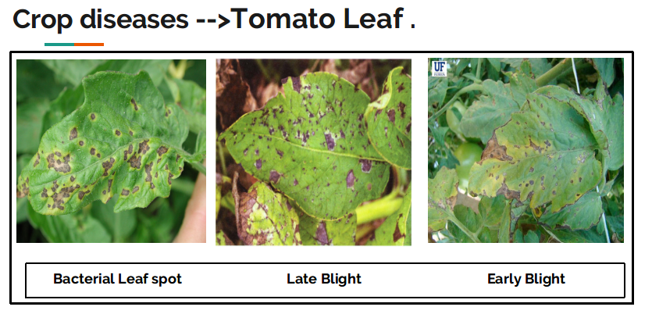

**Similar Symptoms but different diseases.**

In Image-Based Plant Disease Detection with Deep Learning et al. Ashwin Dhakal developed a model which is followed with feature extraction, segmentation and the classification of patterns of captured leaves in order to identify plant leaf diseases. Four classifier labels are used as Bacterial Spot, Yellow Leaf Curl Virus, Late Blight and Healthy Leaf. The features extracted are fit into the neural network with 20 epochs. Several artificial neural network architectures are implemented with the best performance of 98.59% accuracy in determining the plant disease.

Identification of Apple Leaf Diseases Based on Deep Convolutional Neural Networks This paper proposes an accurate identifying approach for apple leaf diseases based on deep convolutional neural networks. It includes generating sufficient pathological images and designing a novel architecture of a deep convolutional neural network based on AlexNet to detect apple leaf diseases. Using a dataset of 13,689 images of diseased apple leaves, the proposed deep convolutional neural network model is trained to identify the four common apple leaf diseases. Under the hold-out test set, the experimental results show that the proposed disease identification approach based on the convolutional neural network achieves an overall accuracy of 97.62%, the model parameters are reduced by 51,206,928 compared with those in the standard AlexNet model, and the accuracy of the proposed model with generated pathological images obtains an improvement of 10.83%. This research indicates that the proposed deep learning model provides a better solution in disease control for apple leaf diseases with high accuracy and a faster convergence rate, and that the image generation technique proposed in this paper can enhance the robustness of the convolutional neural network model.

In Using Deep Learning for Image-Based Plant Disease Detection et al. Prasanna Mohanty train a deep convolutional neural network to identify 14 crop species and 26 diseases (or absence thereof). The trained model achieves an accuracy of 99.35% on a held-out test set, demonstrating the feasibility of this approach. When testing the model on a set of images collected from trusted online sources - i.e. taken under conditions different from the images used for training - the model still achieves an accuracy of 31.4%. While this accuracy is much higher than the one based on random selection (2.6%), a more diverse set of training data is needed to improve the general accuracy. Overall, the approach of training deep learning models on increasingly large and publicly available image datasets presents a clear path towards smartphone-assisted crop disease diagnosis on a massive global scale [1][2][3][4].

# 

# CHAPTER 3

# PROJECT TOOLS

## 3.1 Overview

In this chapter, the Programming languages, Integrated Development Environment (IDE), Libraries, tool and gadgets and softwares are briefly described.

## 3.2 Programming Language

### 

### 3.2.1 Python

Python is a popular programming language. It was created by Guido van Rossum, and released in 1991.Python can be used on a server to create web applications. It is used to solve mathematics and system scripting. It can connect to database systems. It can also read and modify files. Python can be used to handle big data and perform complex mathematics. It can be used for rapid prototyping, or for production-ready software development. It is the recommended language for Raspberry PI coding. Python works on different platforms (Windows, Mac, Linux, Raspberry Pi, etc). Python has a simple syntax similar to the English language. It has syntax that allows developers to write programs with fewer lines than some other programming languages. It runs on an interpreter system, meaning that code can be executed as soon as it is written. This means that prototyping can be very quick. Here we use python for hardware controlling and configuration.

## 3.3 Software And Development Platform

In this section we will discuss various IDEs, operating system and development platforms which are used in our project. Some of them are given below:

### 3.3.1 Jupyter Notebook:

The Jupyter Notebook is an open-source web application that allows you to create and share documents that contain live code, equations, visualizations and explanatory text. Uses include: data cleaning and transformation, numerical simulation, statistical modeling, machine learning and much more. Jupyter Notebook is a living online notebook, letting faculty and students weave together computational information (code, data, statistics) with narrative, multimedia, and graphs. Faculty can use it to set up interactive textbooks, full of explanations and examples which students can test out right from their browsers. Students can use it to explain their reasoning, show their work, and draw connections between their classwork and the world outside. Scientists, journalists, and researchers can use it to open up their data, share the stories behind their computations, and enable future collaboration and innovation.

### 3.3.2 ****Datasets:****

A collection of instances is a dataset and when working with machine learning methods we typically need a few datasets for different purposes.**The training Dataset** A dataset that we feed into our machine learning algorithm to train our model.**The testing Dataset** a dataset that we use to validate the accuracy of our model but is not used to train the model. It may be called the validation dataset.**Instance** is a single row of data is called an instance. It is an observation from the domain.**The Feature** is a single column of data is called a feature. It is a component of an observation and is also called an attribute of a data instance. Some features may be inputs to a model (the predictors) and others may be outputs or the features to be predicted. For this project, we are using the Kaggle website data that's title is “Cotton-Diseased or Fresh”.

### 

### 3.3.3 Keras

Keras is a powerful and easy-to-use free open source Python library for developing and evaluating deep learning models. It wraps the efficient numerical computation libraries Theano and TensorFlow and allows you to define and train neural network models in just a few lines of code. Designed to enable fast experimentation with [deep neural networks](https://en.wikipedia.org/wiki/Deep_learning), it focuses on being user-friendly, modular, and extensible. It was developed as part of the research effort of project ONEIROS (Open-ended Neuro-Electronic Intelligent Robot Operating System),and its primary author and maintainer is François Chollet, a [Google](https://en.wikipedia.org/wiki/Google) engineer. Keras contains numerous implementations of commonly used neural-network building blocks such as layers, [objectives](https://en.wikipedia.org/wiki/Objective_function), [activation functions](https://en.wikipedia.org/wiki/Activation_function), [optimizers](https://en.wikipedia.org/wiki/Mathematical_optimization), and a host of tools to make working with image and text data easier to simplify the coding necessary for writing deep neural network code. Keras has support for [convolutional](https://en.wikipedia.org/wiki/Convolutional_neural_networks) and [recurrent neural networks](https://en.wikipedia.org/wiki/Recurrent_neural_networks). It supports other common utility layers like [dropout](https://en.wikipedia.org/wiki/Dropout_(neural_networks)), [batch normalization](https://en.wikipedia.org/wiki/Batch_normalization), and [pooling](https://en.wikipedia.org/wiki/Pooling_(neural_networks)). In addition to standard neural networks, Keras has support for [convolutional](https://en.wikipedia.org/wiki/Convolutional_neural_networks) and [recurrent neural networks](https://en.wikipedia.org/wiki/Recurrent_neural_networks). It supports other common utility layers like [dropout](https://en.wikipedia.org/wiki/Dropout_(neural_networks)), [batch normalization](https://en.wikipedia.org/wiki/Batch_normalization), and [pooling](https://en.wikipedia.org/wiki/Pooling_(neural_networks)). Keras allows users to productize deep models on smartphones ([iOS](https://en.wikipedia.org/wiki/IOS) and [Android](https://en.wikipedia.org/wiki/Android_(operating_system))), on the web, or on the [Java Virtual Machine](https://en.wikipedia.org/wiki/Java_Virtual_Machine). It also allows use of distributed training of deep-learning models on clusters of [Graphics processing units (GPU)](https://en.wikipedia.org/wiki/Graphics_processing_unit) and [tensor processing units (TPU)](https://en.wikipedia.org/wiki/Tensor_processing_unit).

### 3.3.4 Matplotlib

Matplotlib is a comprehensive library for creating static, animated, and interactive visualizations in Python. Matplotlib makes easy things easy and hard things possible. Create. Develop publication-quality plots with just a few lines of code.

Matplotlib is a library for making 2D plots of arrays in [Python](https://www.python.org/). Although it has its origins in emulating the MATLAB graphics commands, it is independent of MATLAB, and can be used in a Pythonic, object oriented way. Although Matplotlib is written primarily in pure Python, it makes heavy use of [NumPy](https://numpy.org/) and other extension code to provide good performance even for large arrays.Matplotlib is designed with the philosophy that you should be able to create simple plots with just a few commands, or just one! If you want to see a histogram of your data, you shouldn't need to instantiate objects, call methods, set properties, and so on; it should just work.For years, I used to use MATLAB exclusively for data analysis and visualization. MATLAB excels at making nice looking plots easy. When I began working with EEG data, I found that I needed to write applications to interact with my data, and developed an EEG analysis application in MATLAB. As the application grew in complexity, interacting with databases, http servers, manipulating complex data structures, I began to strain against the limitations of MATLAB as a programming language, and decided to start over in Python. Python more than makes up for all of MATLAB's deficiencies as a programming language, but I was having difficulty finding a 2D plotting package (for 3D [VTK](http://www.vtk.org/) more than exceeds all of my needs).

### 

### 3.3.5 [Spyder IDE](https://www.spyder-ide.org/)

Spyder is a powerful scientific environment written in Python, for Python, and designed by and for scientists, engineers and data analysts. It features a unique combination of the advanced editing, analysis, debugging, and profiling functionality of a comprehensive development tool with the data exploration, interactive execution, deep inspection, and beautiful visualization capabilities of a scientific package. Spyder’s documentation provides a variety of resources that will help you learn how to use the application and explore each one of its panes. These include video tutorials, in-depth descriptions and how-to guides covering a wide range of needs and experience levels with Spyder. Spyder’s multi-language **Editor** integrates a number of powerful tools right out of the box for an easy to use, efficient editing experience. The Editor’s key features include syntax highlighting (pygments); real-time code and style analysis (pyflakes and pycodestyle); on-demand completion, calltips and go-to-definition features (rope and jedi); a function/class browser, horizontal and vertical splitting, and much more.

Spyder is written in the same Python language that you use it to develop, so its easy to get started contributing to it. You can follow our [contributing guide](https://github.com/spyder-ide/spyder/blob/master/CONTRIBUTING.md) to set up a development environment, and you can get involved with the project through our [Github repository](https://github.com/spyder-ide). The easiest way to get started is helping us resolve items on our [issue tracker](https://github.com/spyder-ide/spyder/issues), either by fixing bugs in Spyder, or helping users troubleshoot their problems (which doesn’t require writing any code).A “code cell” in Spyder is a block of lines, typically in a script, that can be easily executed all at once in the current [IPython Console](https://docs.spyder-ide.org/current/ipythonconsole.html). This is much like a “cell” in MATLAB (except without any need to enable a “cell mode”, since in Spyder, cells are detected automatically). You can divide your scripts into as many cells as needed, or none at all—the choice is yours.

### 3.3.6 Flask

### Flask is a micro [web framework](https://en.wikipedia.org/wiki/Web_framework) written in [Python](https://en.wikipedia.org/wiki/Python_(programming_language)). It is classified as a [microframework](https://en.wikipedia.org/wiki/Microframework) because it does not require particular tools or libraries. “Micro” does not mean that your whole web application has to fit into a single Python file, although it certainly can. Nor does it mean that Flask is lacking in functionality. The “micro” in microframework means Flask aims to keep the core simple but extensible. Flask won’t make many decisions for you, such as what database to use. Those decisions that it does make, such as what templating engine to use, are easy to change. Everything else is up to you, so that Flask can be everything you need and nothing you don’t.

### By default, Flask does not include a database abstraction layer, form validation or anything else where different libraries already exist that can handle that. Instead, Flask supports extensions to add such functionality to your application as if it was implemented in Flask itself. Numerous extensions provide database integration, form validation, upload handling, various open authentication technologies, and more. Flask may be “micro”, but it’s ready for production use on a variety of needs. Flask has many configuration values, with sensible defaults, and a few conventions when getting started. By convention templates and static files are stored in subdirectories within the application’s Python source tree, with the names templates and static respectively. While this can be changed you usually don’t have to, especially when getting started. Once you have Flask up and running, you’ll find a variety of extensions available in the community to integrate your project for production. The Flask core team reviews extensions and ensures approved extensions do not break with future releases.

### As your codebase grows, you are free to make the design decisions appropriate for your project. Flask will continue to provide a very simple glue layer to the best that Python has to offer. You can implement advanced patterns in SQLAlchemy or another database tool, introduce non-relational data persistence as appropriate, and take advantage of framework-agnostic tools built for WSGI, the Python web interface.

### 

### 3.3.7 HTML

Hypertext Markup Language (HTML) is the standard [markup language](https://en.wikipedia.org/wiki/Markup_language) for documents designed to be displayed in a [web browser](https://en.wikipedia.org/wiki/Web_browser). It can be assisted by technologies such as [Cascading Style Sheets](https://en.wikipedia.org/wiki/Cascading_Style_Sheets) (CSS) and [scripting languages](https://en.wikipedia.org/wiki/Scripting_language) such as [JavaScript](https://en.wikipedia.org/wiki/JavaScript).

[Web browsers](https://en.wikipedia.org/wiki/Web_browser) receive HTML documents from a [web server](https://en.wikipedia.org/wiki/Web_server) or from local storage and [render](https://en.wikipedia.org/wiki/Browser_engine) the documents into multimedia web pages. HTML describes the structure of a [web page](https://en.wikipedia.org/wiki/Web_page) [semantically](https://en.wikipedia.org/wiki/Semantic_Web) and originally included cues for the appearance of the document.

[HTML elements](https://en.wikipedia.org/wiki/HTML_element) are the building blocks of HTML pages. With HTML constructs, [images](https://en.wikipedia.org/wiki/HTML_element#Images_and_objects) and other objects such as [interactive forms](https://en.wikipedia.org/wiki/Fieldset) may be embedded into the rendered page. HTML provides a means to create [structured documents](https://en.wikipedia.org/wiki/Structured_document) by denoting structural [semantics](https://en.wikipedia.org/wiki/Semantics) for text such as headings, paragraphs, lists, [links](https://en.wikipedia.org/wiki/Hyperlink), quotes and other items. HTML elements are delineated by *tags*, written using [angle brackets](https://en.wikipedia.org/wiki/Bracket#Angle_brackets). Tags such as <img /> and <input /> directly introduce content into the page. Other tags such as <p> surround and provide information about document text and may include other tags as sub-elements. Browsers do not display the HTML tags, but use them to interpret the content of the page.

HTML can embed programs written in a [scripting language](https://en.wikipedia.org/wiki/Scripting_language) such as [JavaScript](https://en.wikipedia.org/wiki/JavaScript), which affects the behavior and content of web pages. Inclusion of CSS defines the look and layout of content. The [World Wide Web Consortium](https://en.wikipedia.org/wiki/World_Wide_Web_Consortium) (W3C), former maintainer of the HTML and current maintainer of the CSS standards, has encouraged the use of CSS over explicit presentational HTML since 1997.

### 3.3.8 CSS

Cascading Style Sheets (CSS) is a [style sheet language](https://en.wikipedia.org/wiki/Style_sheet_language) used for describing the [presentation](https://en.wikipedia.org/wiki/Presentation_semantics) of a document written in a [markup language](https://en.wikipedia.org/wiki/Markup_language) such as [HTML](https://en.wikipedia.org/wiki/HTML).[[1]](https://en.wikipedia.org/wiki/CSS#cite_note-1) CSS is a cornerstone technology of the [World Wide Web](https://en.wikipedia.org/wiki/World_Wide_Web), alongside HTML and [JavaScript](https://en.wikipedia.org/wiki/JavaScript).[[2]](https://en.wikipedia.org/wiki/CSS#cite_note-2)

CSS is designed to enable the separation of presentation and content, including [layout](https://en.wikipedia.org/wiki/Page_layout), [colors](https://en.wikipedia.org/wiki/Color), and [fonts](https://en.wikipedia.org/wiki/Typeface).[[3]](https://en.wikipedia.org/wiki/CSS#cite_note-3) This separation can improve content [accessibility](https://en.wikipedia.org/wiki/Accessibility), provide more flexibility and control in the specification of presentation characteristics, enable multiple [web pages](https://en.wikipedia.org/wiki/Web_page) to share formatting by specifying the relevant CSS in a separate .css file which reduces complexity and repetition in the structural content as well as enabling the .css file to be [cached](https://en.wikipedia.org/wiki/Cache_(computing)) to improve the page load speed between the pages that share the file and its formatting.

Separation of formatting and content also makes it feasible to present the same markup page in different styles for different rendering methods, such as on-screen, in print, by voice (via speech-based browser or [screen reader](https://en.wikipedia.org/wiki/Screen_reader)), and on [Braille-based](https://en.wikipedia.org/wiki/Braille_display) tactile devices. CSS also has rules for alternate formatting if the content is accessed on a [mobile device](https://en.wikipedia.org/wiki/Mobile_device).[[4]](https://en.wikipedia.org/wiki/CSS#cite_note-4)

The name *cascading* comes from the specified priority scheme to determine which style rule applies if more than one rule matches a particular element. This cascading priority scheme is predictable. The CSS specifications are maintained by the [World Wide Web Consortium](https://en.wikipedia.org/wiki/World_Wide_Web_Consortium) (W3C). Internet media type ([MIME type](https://en.wikipedia.org/wiki/MIME_media_type))  is registered for use with CSS by [RFC 2318](https://tools.ietf.org/html/rfc2318) (March 1998). The W3C operates a free [CSS validation service](https://en.wikipedia.org/wiki/W3C_Markup_Validation_Service#CSS_validation) for CSS documents.

# CHAPTER 4

# METHODOLOGY

## 4.1Overview:

In this chapter, the Step By Step Methodology of the project is described along with data flow diagrams, App previews and Connection Diagram.

## 

## 4.2 Datasets:

A collection of instances is a dataset and when working with machine learning methods we typically need a few datasets for different purposes. This dataset contains the images of diseased and fresh cotton leaves and plants. The dataset is divided into three sub directories of train test and validation. Each with each of the classes like diseased or fresh. **The training Dataset** A dataset that we feed into our machine learning algorithm to train our model. **Testing Dataset which dataset then we test the model and find the model accuracy.**

Data validation means checking the accuracy and quality of source data before using, importing or otherwise processing data. Different types of validation can be performed depending on destination constraints or objectives. Data validation is a form of data cleansing.

## 

## 4.3 Model building:

In this method, we will discuss a step-by-step methodology model building and training.

### 4.3.1 Image Augmentation:

Image augmentationis atechnique that is used to artificially expand the data-set. This is helpful when we are given a data-set with very few data samples. In case of Deep Learning, this situation is bad as the model tends to over-fit when we train it on limited number of data samples.

Image augmentation parameters that are generally used to increase the data sample count are zoom, shear, rotation, preprocessing_function and so on. Usage of these parameters results in generation of images having these attributes during training of Deep Learning model. Image samples generated using image augmentation, in general results in increase of existing data sample set by nearly 3x to 4x times.

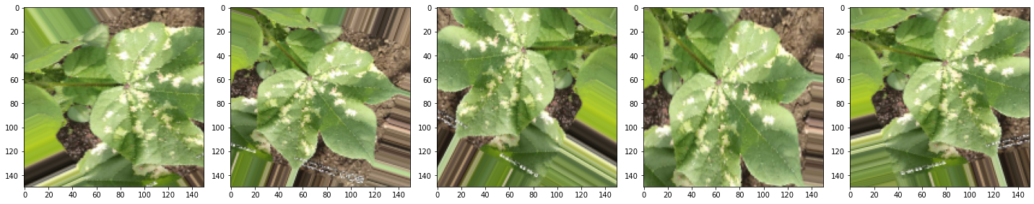Images in the dataset may be in different formats, quality and resolution. Hence, the images need to be preprocessed, for instance, images with smaller resolution and dimension less than 500 px will not considered as valid images for the dataset. The rest will be resized to 150 × 150 in order to reduce the time for training.

**Figure 4.1** Preprocessing image

### 4.3.2 Training:

In this step, we use deep learning algorithms convolutional neural network for making an image classification model will be done. Rectified Linear Units (ReLU) will subsequently be used as substitute for saturating nonlinearities. This activation function adaptively will learn the parameters of rectifiers and improve accuracy at negligible extra computational cost.

### 4.3.2.1 Convolutional Neural Network:

A convolutional neural network (CNN) is a type of artificial neural network used in image recognition and processing that is specifically designed to process pixel data. A **Convolutional Neural Network** is a Deep Learning algorithm which can take in an input image, assign importance (learnable weights and biases) to various aspects/objects in the image and be able to differentiate one from the other. The pre-processing required in a ConvNet is much lower as compared to other classification algorithms. While in primitive methods filters are hand-engineered, with enough training, ConvNets have the ability to learn these filters/characteristics.

The architecture of a ConvNet is analogous to that of the connectivity pattern of Neurons in the Human Brain and was inspired by the organization of the Visual Cortex. Individual neurons respond to stimuli only in a restricted region of the visual field known as the Receptive Field. A collection of such fields overlap to cover the entire visual area.

I searched for best algorithm to solve this problem and I select “Convolution Neural Network” (CNN). I create my own CNN architecture and it works well on the training and as well as testing dataset. It gives me more than 98% accuracy on training and validation data set in just 500 epochs. I am trying to increase accuracy with more data and epochs.

### 4.3.2.2 Rectified Linear Units (ReLU):

The Rectified Linear Unit is the most commonly used activation function in deep learning models. The function returns 0 if it receives any negative input, but for any positive value x it returns that value back. So it can be written as f(x)=max(0,x). In a neural network, the activation function is responsible for transforming the summed weighted input from the node into the activation of the node or output for that input.

The **rectified linear activation function**or **ReLU**for short is a piecewise linear function that will output the input directly if it is positive, otherwise, it will output zero. It has become the default activation function for many types of neural networks because a model that uses it is easier to train and often achieves better performance.

In this project, you will use the rectified linear activation function for deep learning neural networks.

Graphically it looks like this

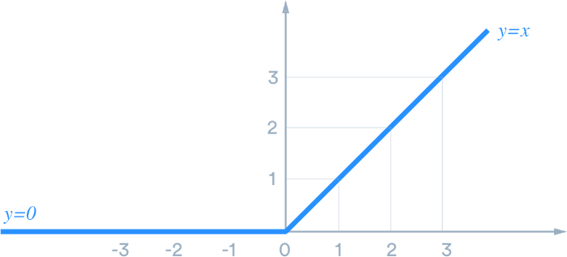

### 4.3.3 Testing:

In this phase, the test set for prediction of leaf as healthy/Unhealthy with its disease name will be used to evaluate the performance of the classifier.

### 4.3.4 Model Accuracy:

Accuracy is one metric for evaluating classification models. Informally, accuracy is the fraction of predictions our model got right. Formally, accuracy has the following definition: Accuracy = Number of correct predictions Total number of predictions.

The following model is my project accuracy model to show the model accuracy then we show time to time model increase accuracy with every epoch. They also show to I will increase the epoch the accuracy of the model also increase.

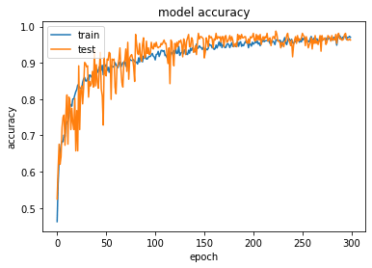

### 4.4.5 Model Loss

The loss function is incredibly simple: It’s a method of evaluating how well your algorithm models your dataset. If your predictions are totally off, your loss function will output a higher number. If they’re pretty good, it’ll output a lower number. As you change pieces of your algorithm to try and improve your model, your loss function will tell you if you’re getting anywhere.

The following model is my project loss model to show the model loss then we show time to time model decrease loss with every epoch. They also show to I will increase the epoch the loss of the model also decrease.

Graphically it looks like this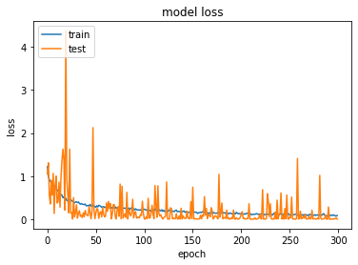

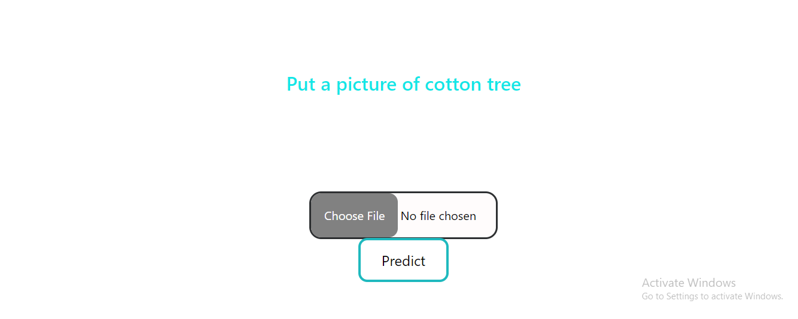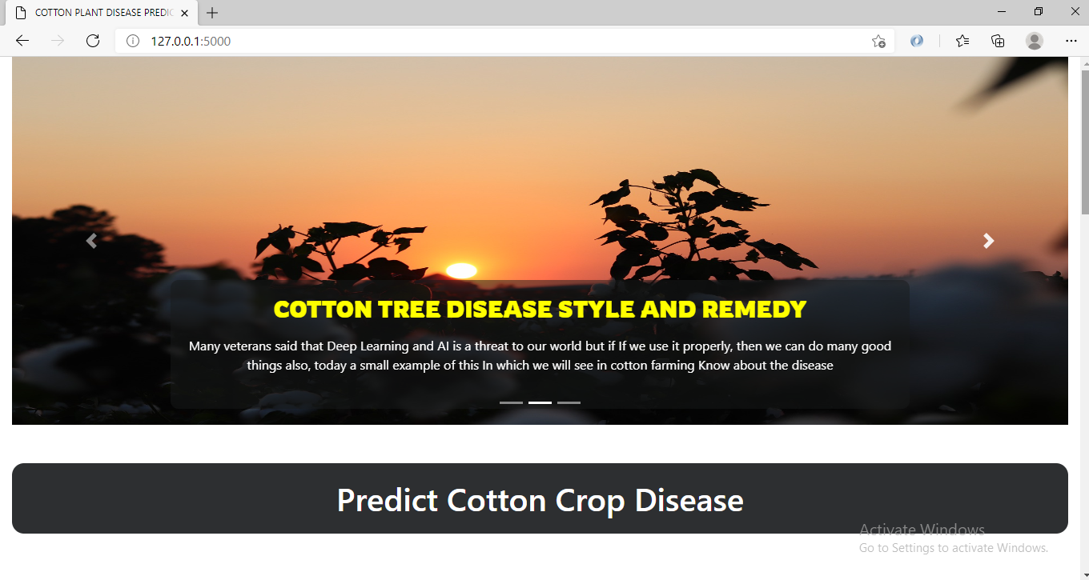4.4 Web Application:

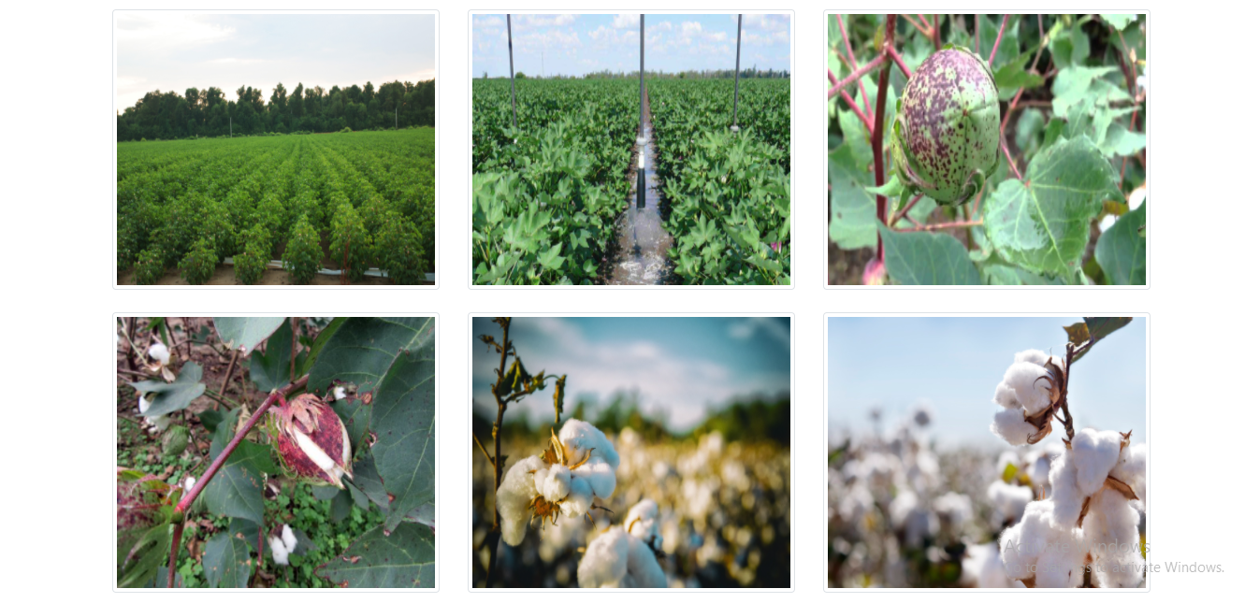



This is the main page of that web application. For putting the image click the Choose File. After putting in the image then the clicks Predict button. When click predict button the application shows me that the cotton leaf or plant is diseased or not.

### 

### 4.4.1 Diseased Cotton plant:

If we put the Diseased Cotton plant images that, show me this Cotton Plant Diseased and diseased name Attack of Leaf Sucking and Chewing Pests. And also show me this type of diseased solution.

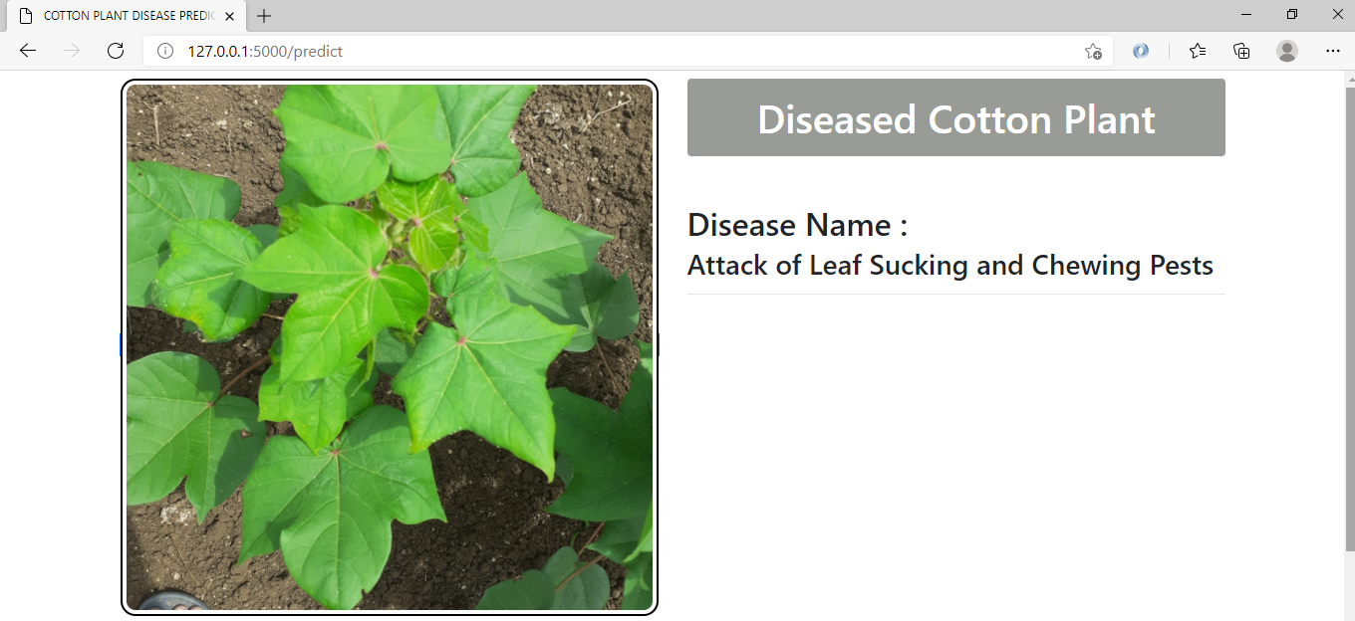

### 

### 4.4.2 Healthy Cotton Plant:

If we put the healthy Cotton plant images then show me there is no disease on the cotton Plant.

### 

### 4.4.3 Healthy Cotton plant Leaf:

If the chemical fertilizer has fallen on the leaves of the leaf, then show me there is no disease on the cotton plant. Although the chemical fertilizer has fallen on the leaves of the tree, the leaves are burnt, but there is no need to worry.

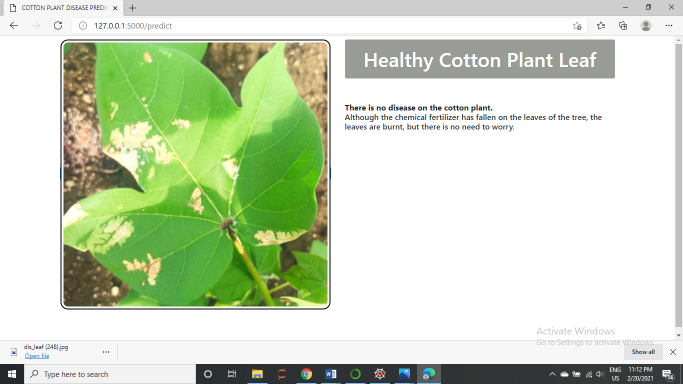

# 

# CHAPTER 5

# ADVANTAGES & LIMITATIONS

## 5.1 Overview

In this chapter, the Advantages of the project and Limitations of the project are described.

## 5.2 Advantages:

a) Benefits: This project is going to help the farmers mainly. From increasing the productivity to cost-saving, this model is going to help the farmers of the country mainly.

b) Cost Saving: The primary reason due to the production of the cotton crop has decreased over time is the high production cost of the crop for the farmers. So, this project is going to help the farmers in solving this problem by giving them an online purchase option from the pesticide's companies. Other cities, and one city has many fields in it. So sometimes it takes one or more days field officer to go and check the health of the plant. There are few diseases in cotton which can destroy the cotton plant in a day. So, this project will give the diagnosis and recommendation at the same time and the biological and chemical control.

## Higher Accuracy: The cotton care model will be more efficient in diagnosing the cotton diseases the traditional methods. The cotton care model is based on machine learning, so it will have higher accuracy than the human experts.

## Recommendation System: The model will recommendation and advises on the usage of the pesticides in crop. It will also give the monitoring suggestions from the start for the care of cotton crop until the yield.

Higher Production: This system will ultimately be going to help to increase the production of the cotton crop, which will be beneficial for the farmers as well as for the country

## 5.3 Limitations

The limitation(s) of the Project is/are:

a) Response depends upon the internet speed.

**CHAPTER 6**

# CONCLUSION AND FUTURE WORK

## 6.1 Overview

In this chapter, the final conclusion about the project and Future work is described.

## 6.2 Conclusion:

The world population is increasing at the rate of 1.08% every year. The demand for food will improve with time. So, we must get maximum production from agriculture fields to satisfy the requirements. This Project aimed to study and understand the diseases in cotton crop and to develop a model based on deep learning which can detection the cotton diseases. The work starts with the background and introduction of the cotton crop, the problems the cotton crop is facing and the objectives of our project, which are going to help to solve these problems. A literature review was done after to have a good idea on the recent researches done on detection of the diseases in cotton crop. After the literature, the thesis focuses on the methodology used in making of the model; it includes the project description followed by the components used in and their physical properties. Following that is the experimental result where it concludes that in this thesis work and project designing, the model was successfully developed, which can easily be used on cross-platform. After the designing of the model, the accuracy levels were checked on different cotton diseases.

“Cotton Plants disease detection Web App” Project is a low-cost, affordable and implementable project without costing a huge amount and making big changes in the current Production of cotton crops.

## 

## 6.3 Future Work:

In future work, we will extend our database for more plant disease identification and use large number of data as training purpose in classification. I will train the model with multiple plants disease after that this app gives a lot of advantages in the agriculture sector. As we increase the training data, the accuracy of system will be high. And then we can compare the accuracy rate and speed of system.

# 

# References

[1] Dubey, Yogita K., Milind M. Mushrif, and Sonam Tiple. "Superpixel based roughness measure for cotton leaf diseases detection and classification." In 2018 4th International Conference on Recent Advances in Information Technology (RAIT), pp. 1-5. IEEE, 2018.

[2] Dhinesh, E., and A. Jagan. "Detection of Leaf Disease Using Principal Component Analysis and Linear Support Vector Machine." In 2019 11th International Conference on Advanced Computing (ICoAC), pp. 350-355. IEEE, 2019.

[3] Khirade, Sachin D., and A. B. Patil. "Plant disease detection using image processing." In 2015 International conference on computing communication control and automation, pp. 768-771. IEEE, 2015.

[4] Crop: Plant Disease Identification Using Mobile App. | by.  
  
[5] Image-Based Plant Disease Detection with Deep Learning Ashwin Dhakal1, Prof. Dr. Subarna Shakya2 ISSN: 2231 – 2803 <http://www.ijcttjournal.org>

[6] Identification of Apple Leaf Diseases Based on Deep Convolutional Neural Networks, Bin Liu 1,2,*,† Yun Zhang 1,†, DongJian He 2,3 and Yuxiang Li 4, Symmetry 2018, 10, 11; doi:10.3390/sym10010011

[7] Using Deep Learning for Image-Based Plant Disease Detection Sharada Prasanna Mohanty1,2, David Hughes3,4,5, and Marcel Salathé1,2,6 April 15, 2016 | 1 <https://arxiv.org/pdf/1604.03169>

[8] Data set: <https://www.kaggle.com/ananysharma/diseasecotton?select=data>

[9] ["Flask Foreword"](https://web.archive.org/web/20171117015927/http:/flask.pocoo.org/docs/0.10/foreword). Archived from [the original](http://flask.pocoo.org/docs/0.10/foreword) on 2017-11-17.

[10]["Core - Keras Documentation"](https://keras.io/layers/core/). keras.io. Retrieved 2018-11-14.

[11]["Why use Keras"](https://keras.io/why-use-keras/). keras.io. Retrieved 2020-03-22.

[12] [HTML 4.0 Specification — W3C Recommendation — Conformance: requirements and recommendations"](https://www.w3.org/TR/REC-html40-971218/conform.html#deprecated). w3. World Wide Web Consortium. December 18, 1997. [Archived](https://web.archive.org/web/20150705040855/http:/www.w3.org/TR/REC-html40-971218/conform.html) from the original on July 5, 2015. Retrieved July 6, 2015.

[13] CSS developer guide. Mozilla Developer Network. [Archived](https://web.archive.org/web/20150925133829/https:/developer.mozilla.org/en-US/docs/Web/Guide/CSS) from the original on 2015-09-25. Retrieved 2015-09-24.

[14] Flanagan, David. JavaScript – The definitive guide (6ed.). p. 1. JavaScript is part of the triad of technologies that all Web developers must learn: HTML to specify the content of web pages, CSS to specify the presentation of web pages, and JavaScript to specify the behaviour of web pages.

[15]["What is CSS?"](http://www.w3.org/standards/webdesign/htmlcss#whatcss). World Wide Web Consortium. [Archived](https://web.archive.org/web/20101129081921/http:/www.w3.org/standards/webdesign/htmlcss#whatcss) from the original on 2010-11-29. Retrieved 2010-12-01